2019

|  |
| --- |
| Done by: Rajalakshmanan.C  Unique_id:E0219054  Programme:Btech CSE(Cys and Iot |



|  |  |
| --- | --- |
| autonomous car | Iot project report |

SRI RAMACHANDRA ENGINEERING AND TECHNOLOGY

IOT Basics-1 (CSE -130)-PROJECT REPORT

NAME OF THE CANDIDATE: RAJALAKSHMANAN.C

UNIQUE ID : E0219054

COURSE : B-Tech (Cs and IOT)

Project :Autonomous Car

ABOUT THE PROJECT:

* My project is on basic autonomous car which works on its own .In the process it uses the ultrasonic senor to identify the obstacle in front of it and operates itself in the other direction.
* This project runs with the help Arduino Uno r3 board in the source code has been uploaded for its working i.e to identify the obstacle, functions to turn , connectivity of the pins and to give the power supply from the external source.
* Actually this project works in the following ways:

First we need 4 9v battery to give power supply to the Arduino board and motor module

And then it starts to work the servo motor starts to rotate between the angle of 0-180 degree .Since I have attached ultrasonic sensor with servo the ultrasonic sensor can sense the obstacle in front of between 0-180 degree.

I have set 15cm range for the ultrasonic sensor to identify the obstacles with in this range.

And in this when the ultrasonic sensor senses the obstacle infront of it the motor module controls the 4 motor in such a way that the motor pair of a side lows it power and the other side highs its power to turn the car.

DESIGN OF THE PROJECT:

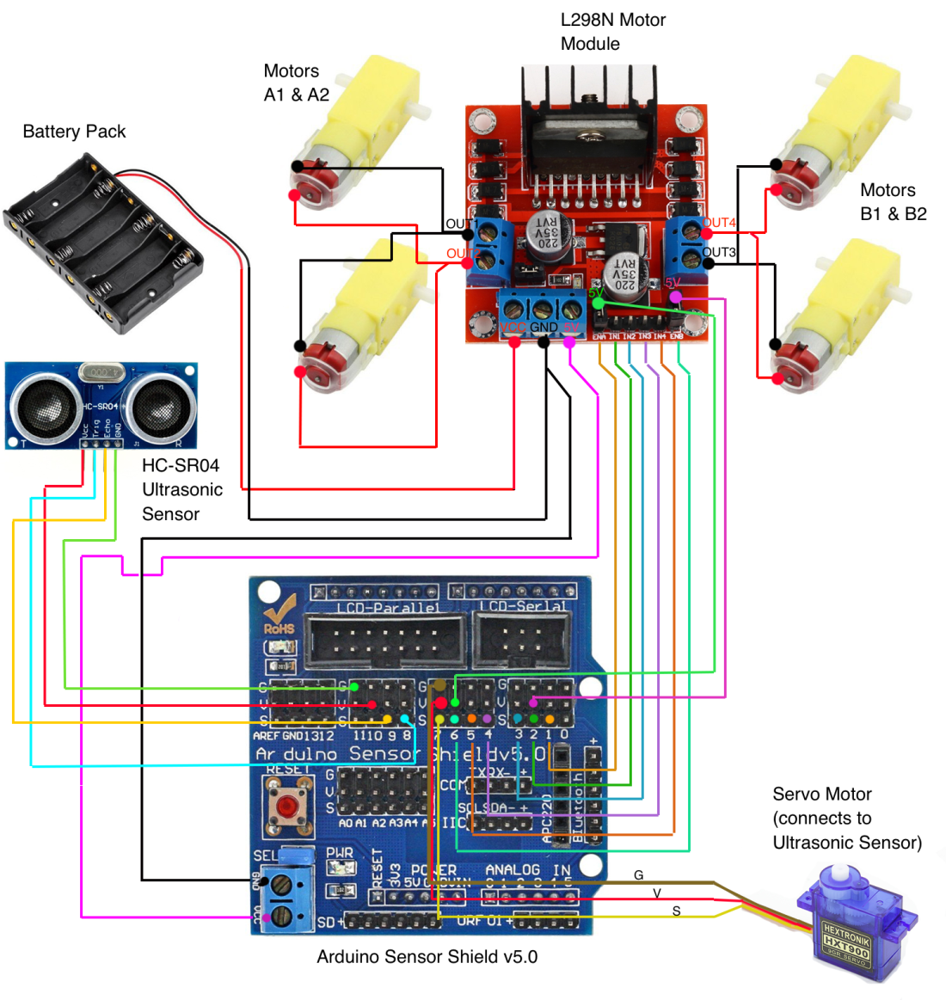

In this I have connected the 2 motors together at the one of the motor module and other 2 at the other side of the motor module. This is to lower and higher the voltage to turn the car .I have connected the ultrasonic sensor and servo motor together to sense the obstacle and between 0-180 degree.

Instead of battery jack I have used 2 9v battery to give power supply to the motor module and again I have connected other 2 9v battery to Arduino for its power supply.

I have sensor shield to give the connections between the components and the Arduino .After the connection made in the sensor shield place the sensor shield over the Arduino in such way that all the pins fit into the pins of Arduino board.

1. Connect the red wire (voltage) from the battery enclosure to VCC on the L298N Motor Module.

2. Connect the black wire (ground) from the battery enclosure to GND on the Motor Module.

3. Connect the red wire from Motor A1 (rear left) and the red wire from Motor A2 (front left) to OUT1 on the Motor Module (both wires can be twisted together and will go into OUT1 – the wiring diagram further down this page shows how to do this).

4. Connect the black wire from Motor A1 (rear left) and the black wire from Motor A2 (front left) to OUT2 on the Motor Module.

5. Connect the red wire from Motor B1 (rear right) and the red wire from Motor B2 (front right) to OUT3 on the Motor Module.

6. Connect the black wire from Motor B1 (rear right) and the black wire from Motor B2 (front right) to OUT4 on the Motor Module.

7. Connect a female-to-female end wire from ENA (Engine A) on the Motor Module to signal pin 1 on the Sensor Shield (the #2 pin in the S row. There are three rows – S stands for Signal, V for Voltage and G for Ground).

8. Connect a female-to-female end wire from 5V (next to ENA) on the Motor Module to voltage pin 1 on the Sensor Shield (it doesn’t really matter which pin for voltage as long as it is in the V row).

9. Connect a female-to-female end wire from IN1 on the Motor Module to signal pin 2 on the Sensor Shield.

10. Connect a female-to-female end wire from IN2 on the Motor Module to signal pin 3 on the Sensor Shield.

11. Connect a female-to-female end wire from IN3 on the Motor Module to signal pin 4 on the Sensor Shield.

12. Connect a female-to-female end wire from IN4 on the Motor Module to signal pin 5 on the Sensor Shield.

13.Connect a female-to-female end wire from 5V (next to ENB) on the Motor Module to voltage pin 6 on the Sensor Shield (it doesn’t really matter which pin for voltage as long as it is in the V row).

14. Connect a female-to-female end wire from ENB (Engine B) on the Motor Module to signal pin 6 on the Sensor Shield.

15. Connect the signal wire from the servo motor to signal (S) pin 7 on the Sensor Shield, the voltage wire from the servo motor to the voltage (V) pin 7 on the Sensor Shield, and the ground wire from the servo motor to the GND (G) pin 7 on the Sensor Shield.

16. Attach the Ultrasonic Sensor to the servo motor and then attach the servo motor to the front of the car so that it can scan left and right looking for objects in its [path](https://www.codemahal.com/glossary/path/).  
You can use sticky tape, blu-tack, glue or a 3D printed/laser cut mount or whatever you like to attach everything, as long as everything is firmly mounted.

17. Use female-to-female end plugs to connect the Ultrasonic sensor to the Sensor Shield. Firstly, attach the TRIG pin from the Ultrasonic sensor to signal (S) pin 8 on the Sensor Shield. Attach the ECHO pin from the ultrasonic sensor to signal (S) pin 9 on the Sensor Shield. Attach the VCC pin from the Ultrasonic Sensor to the voltage (V) pin 10 on the Sensor Shield. Lastly, attach the GND pin from the Ultrasonic Sensor to the GND (G) pin 11 on the Sensor Shield.

18. Now attach the Sensor Shield on top of the Arduino Uno board making sure to not bend any pins. Connect a 9V Battery Barrel Jack Connector to a 9V battery and then plug this in to the Arduino’s barrel jack (see diagram below).

19. That’s it! Now all you need is batteries and the code!

COMPONTENTS USED IN THE PROJECT:

1x Arduino Uno board

4 wheels, 4 motors

4x 9v battery

1x 9V battery power cable barrel jack connector

1x L298N Motor Module

1x Arduino Sensor Shield v5.0

1x HC-SR04 Ultrasonic Sensor

1x Servo motor

4x female-to-female wires for Ultrasonic Sensor

8x female-to-female wires for the Motor Module to Sensor Shield

8x bare-ended wires to go from the four motors to the Motor Module

2x bare-ended wires to go from the Motor Module to Sensor Shield

3x wires for the servo motor with female end attaching to Sensor Shield

4 bare wires

9v battery connector 4

Arduino [IDE](https://www.codemahal.com/glossary/ide/) software – free at [http://www.arduino.cc](http://www.arduino.cc/)

USB cable (A male plug to B male plug)

A computer to program with

PROJECT PHOTOS:

